Cell Division
- Explain how cell division is used in:

  - Unicellular organisms
_____________________________________________________________________________
_____________________________________________________________________________
_____________________________________________________________________________

  - Multicellular organisms
_____________________________________________________________________________
_____________________________________________________________________________
_____________________________________________________________________________

- Diagram 1 shows the nucleus of a body cell as it begins to divide by mitosis.
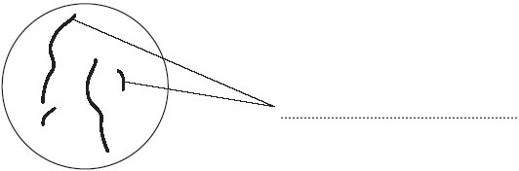
Diagram 1
- Use a word from the box to label Diagram 1.

alleles chromosomes gametes

b. Complete Diagram 2 to show what the nucleus of one of the cells produced by this mitosis would look like.
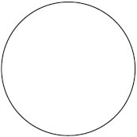
Diagram 2

- Order the following statements to show the order of events during the cell cycle.

- Two new identical daughter cells are produced
- The cytoplasm and cell membrane divides
- The chromosomes are pulled apart to separate ends of the cell
- The cell grows and doubles its sub-cellular structures and replicates its DNA
- The chromosomes line up along the centre of the cell before being pulled by spindle fibres

Order:

_______ _______ _______ _______ _______

- Explain why the DNA and sub-cellular structures must be replicated before the cell divides.
_____________________________________________________________________________
_____________________________________________________________________________
_____________________________________________________________________________

- Suggest why mitosis may happen more frequently in young organisms than mature ones.
_____________________________________________________________________________
_____________________________________________________________________________
_____________________________________________________________________________

Stretch Activity:
There are two types of cell division – mitosis and meiosis. Mitosis is used for growth, repair and asexual reproduction. Meiosis is used for the production of sex cells. Suggest how the process of meiosis is different to mitosis, considering their different outcomes.

